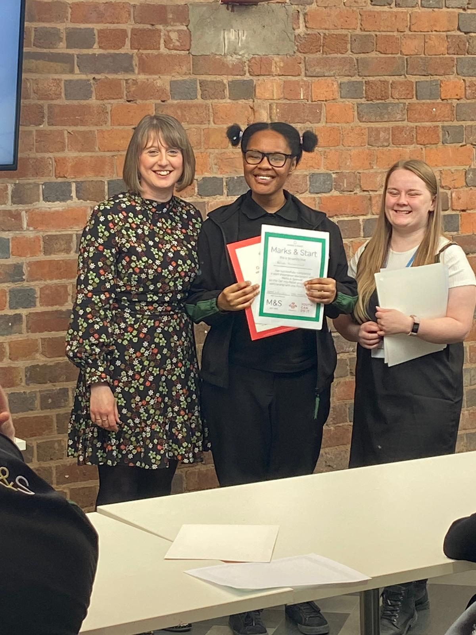

Kate would attend all Prince’s Trust events, workshops included, her favourite were the celebration events where she loved to present the young people with their certificates (Kate is missing as she’s the proud photographer!)