Hosting Therese Coffey, Secretary of State for Work and Pensions, for her visit to M&S in Clapham Store.
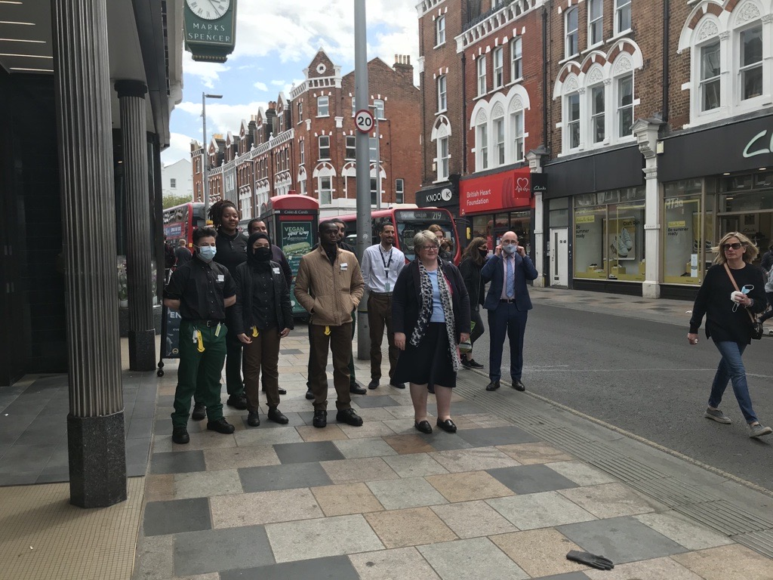

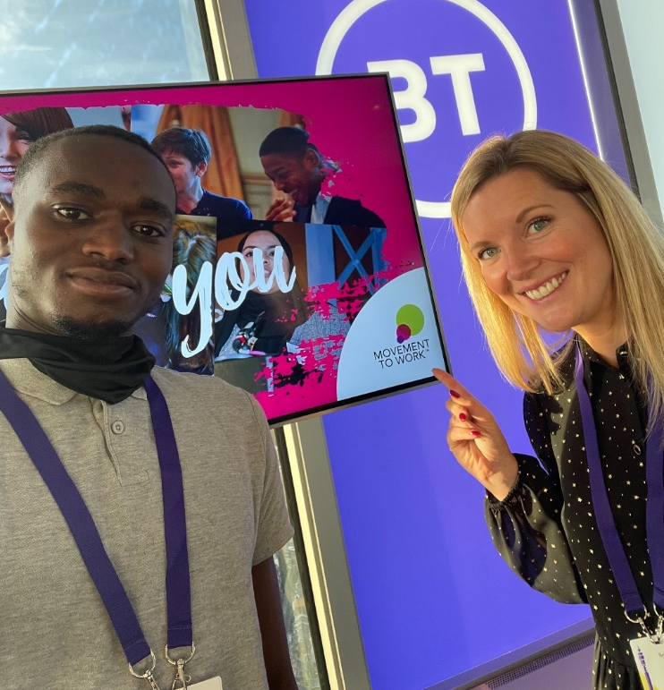

Josiah attended the MTW Youth Employability Summit at the BT Tower of London

Josiah has attended numerous Kickstart events internally helping to support the new generation of Kickstart colleagues. This was him at their Celebration event.
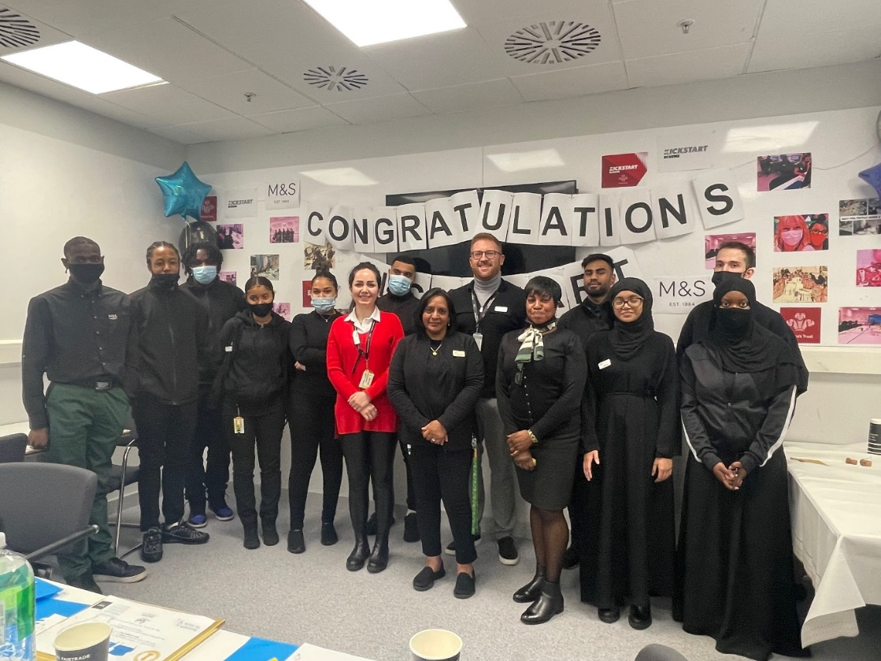

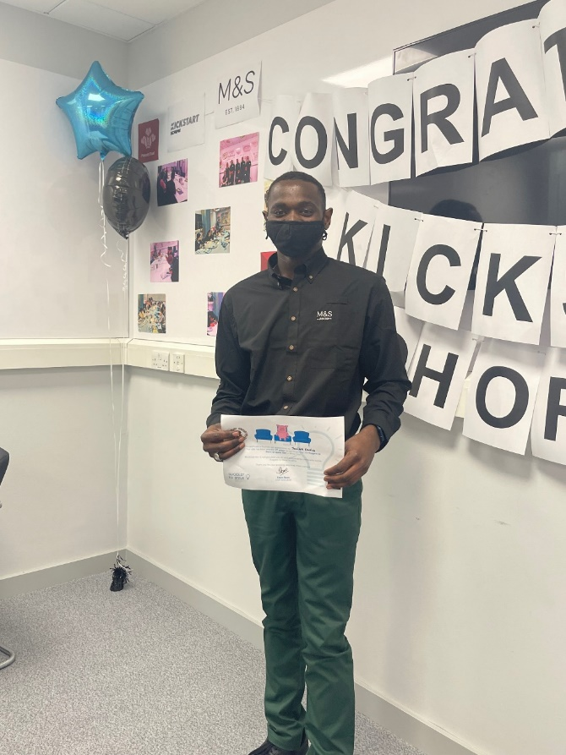
Josiah has contributed several ideas to the business on how
Things could be improved at M&S. This was him receiving
a certificate of recognition for his great idea at the
Suggest to Steve event.

