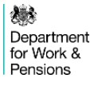
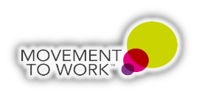
Innovator of the Year Award

An organisation, group or individual that has taken innovative action to adapt to the working world during COVID-19, continuing to provide opportunities for young people in the difficult and changing environment.

I would like to nominate my amazing team The Department for Work and Pensions (DWP) Central Movement to Work Team, for their innovation, creative thinking and tireless effort by leading the way for the Civil Service and creating, testing and implementing a new Virtual Movement to Work (MtW) programme across DWP that is now also being adopted across the wider Civil Service
At the start of the covid-19 pandemic, traditional face to face Movement to Work placements were paused, this occurred at the same time as unemployment figures nationwide increased, especially affecting young people. The pandemic was also having a negative impact on their economic and social wellbeing including financial anxieties, poor mental health and feelings of loneliness and boredom.
The pandemic had also directly impacted my team and as a result they were managing significant challenges themselves. Despite this they demonstrated resilience, passion, and focused on challenging themselves to think innovatively about how to provide the best work experience for young people during these challenging and unprecedented times. They understood the impact of not acting and how imperative it was that they worked quickly and collaboratively with both internal and external stakeholders and colleagues to help identify alternative solutions for delivering MtW. This included seeking and sharing best practice with the Movement to Work Charity and other MtW employers.
Their efforts resulted in a virtual MtW programme that could be used to support young people from diverse backgrounds and with diverse needs. The programme provided Participant Managers with the ability to modify the content to help participants have a better understanding of their local labour markets and to help them find work in the area where they lived. Content of the programme included suggestions for:
- Advice and support for Participant Managers
- Ice breakers for the participants to help them integrate with and get to know other participants
- Projects that the participants could complete during their placement
- Employability skills learning
- How to write a good CV
- Interview skills
- Digital skills
- Further learning for participants including hyperlinks to specific websites
The programme involved different ways of working for DWP colleagues, who were more familiar with face to face contact with young people, therefore, my team developed interactive sessions with Participant Managers to help them adjust to this change.
The decision was made to develop the programme in an agile way so that insight could be gathered throughout from Participants, Participant Managers, stakeholders and DWP colleagues to ensure that the programme was safe secure and meaningful.
Throughout the development of the virtual MtW my team worked collaboratively with colleagues across DWP seeking insight from Service Delivery, Health and Safety, and Security experts to help us develop a viable programme at pace. This was a challenging time for these colleagues in DWP as they were on the frontline responding to the impact of the pandemic.
My team showed genuine appreciation for this and invested significant effort by leading the development of the new virtual programme including:
- Exploring different options for a virtual MtW programme and taking advice from subject matter experts to ensure the participants and participant managers experience was safe secure and meaningful. The approach agreed was to have a two-week placement with a participant manager supporting a cohort of up to 6 participants where interaction with participants would be telephone and email only. Initially my team had hoped to use video channels to engage with participants, however this initially presented with too many risks around H&S and Security and would delay implementation. So, they decided to press ahead and test this approach and once tested would consider a further iteration which would include the use of video. Their initial concerns around this were unfounded as feedback from participants showed that some preferred not having to use their video camera as they lacked confidence doing so.
- Exploring Health and Safety and Security implications for the content of the programme, participants, and Participant Managers. This was challenging as the young people would not be in a DWP building for the duration of their placement. The team had to make sure the programme content was meaningful and developed participants skills and confidence as well as aligning with DWP security and data protection standards. They also had to ensure there were protocols in place to ensure the safety of the participants for example actions to take should a participant not turn up to one of the sessions, to protect their personal information and what action needed to be taken should a participant behave inappropriately in front of other participants.
- Maintained and forged excellent relationships during a time of rapid turnover of colleagues across DWP, many changing job roles to accommodate the pandemic. Working in collaboration with DWP Service Delivery senior MtW leads my team built a network of MtW area leads across DWP who supported my team by attending regular network meetings, reviewing and feedback on our products and helping us understand the impact on our customers and DWP business.
- Drafting and sharing communications to promote and update all stakeholders including DWP colleagues, Trade Unions, and DWP senior leaders to brief them on progress of the virtual MtW programme.
- MtW Intranet site – Developing, promoting and maintaining a brand-new intranet site as a point of reference and is available for over 100,000 DWP employees to view.
- Developing new products and guidance all of which we ensured were accessibility compliant before being successfully tested by colleagues in two districts before being updated following feedback and being shared wider including:
  - Participant Manager Toolkit, a step by step guide to help them run and support MtW participants.
  - Participants toolkit containing useful information to guide them through their MtW placement.
  - Health and Safety and Security Impact assessments, Bespoke Display Screen Equipment checklist, and a Health and Safety prompt sheet to help participant Managers understand the actions to take when preparing to take on participants.
  - Confidentiality and Consent forms for sharing data.
  - Learning plan and learning diary for participants to use to record their learning journey.
  - MtW FAQs.
  - MtW Certificate of Achievement.
  - Fact sheet for Work Coaches to help them when referring participants for a MtW placement. This product was useful as DWP had recently recruited many new Work Coaches to help DWP respond to the impact of the pandemic.
- Developing comprehensive guidelines for gathering data, including building a database enabling the team to substantiate concerns and provide accurate informed data.
- Opportunity for colleagues in DWP to develop their skills including, delivering in a virtual forum, providing outstanding leadership, and networking with diverse teams.
- Launch Events - Provided learning and upskilling for over 650 Participant Managers. This involved talking them through the virtual MtW programme to help them understand the content and providing support to help them with delivering this in their specific business areas.
- Leadership Sessions for Participant Managers – Topics included:
  - How to best help your MtW Participant.
  - What does a good placement Look Like?
  - Security and Accessing the system.
  - How being a Participant Manager helps career progression?

Through developing and maintaining excellent relationships across DWP there have been some brilliant examples of how teams across the country have worked together to deliver high quality placements that have really made a difference and have helped young people from all backgrounds including those with specific needs.
At the forefront of everything my team strived to achieve was to consider the needs of the young people and make sure the programme they developed provided a safe, secure, and meaningful placement. Although my team is small in numbers, feedback they have received from Participants, Participant Managers, stakeholders and DWP colleagues confirms they have worked at pace and developed and delivered something amazing.
"I found the experience extremely informative and useful for my future career path. the support during and after the programme is excellent, with a person-centred approach throughout." Say’s Scott Keegan - a participant from the testing and now a youth ambassador for MTW in DWP
Figure 1 Scott Keegan

After testing and evaluating our new virtual MtW programme was launched nationally across DWP in January in 2021. Since then the programme has gone from strength to strength. To date, since virtual launched on 11 January 2021, the Civil Service have helped 1059 participants by providing them with a placement in DWP and shortly after finishing their placement 55% of participants have started work.
Quarter | Started | Completed | Completed | % Completed | Found Employment | % Found Employment
Q1 (Jan-Mar) | 356 | 308 | 308 | 87% | 190 | 62%
Q2 (Apr-Jun) | 328 | 288 | 288 | 88% | 156 | 54%
Q3 (Jul-Sep) | 213 | 179 | 179 | 84% | 97 | 54%
Q4 (Oct-Dec) | 162 | 143 | 143 | 88% | 64 | 45%
Total | 1059 | 918 | 918 | 87% | 507 | 55%

My team continue to expand our virtual MtW programme for use across the Civil Service and are holding regular calls with other government department colleagues listening and understanding their position and sharing best practice and working with external partners, including the MtW charity, to adapt the virtual framework to suit their organisations. With my teams support four other government departments have already successfully delivered MtW virtually and received positive feedback from participants with 50% securing work almost immediately.

Although statistics and data are important, what is more important is that these placements helped, supported, developed, and motivated young people during the most difficult period in a generation, the impact the team had where we could see the difference between candidates on day 1 and the end of their placement was insurmountable” says Donna Simmons the DWP Lead for MTW.
Figure 2 Donna Simmons

My team proactively sought feedback from participants, Participant Managers stakeholders and DWP colleagues. They have received some amazing feedback some of which we have included in this nomination. As a result of feedback and the relaxation of restrictions implemented because of the Covid-19 pandemic we are now adopting a hybrid approach for MtW placements, making them even more inclusive for more young people and giving them experience of what it is like to work both in an office environment and remotely.
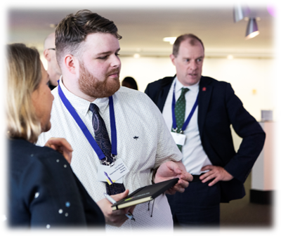
“Before starting my Movement to work I was thinking what I can possibly get from this. After the introduction from the host Linda Creaven, I felt more confident about partaking. It was a time in my life where I felt like stuff was starting to happen and I was feeling recognized.” Says Gavin Phipps, who came through a MTW placement in DWP and is now a DWP Youth ambassador.
Figure 3 Gavin Phipps

“The virtual MtW programme not only put the participants outside of their comfort zones, but also myself! I really enjoyed delivering the two-week programme and felt it helped me so much in building my confidence and my knowledge of the virtual world. I was very proud of the participants who completed the programme with me and was sorry when it came to an end. It’s a fantastic opportunity if you have the chance to be involved.” Says Helen Colley a participant manager.
Figure 4 Helen Colley

In summary my team and I feel that introducing our Virtual MtW programme in DWP and the wider Civil Service has been exciting, rewarding, challenging and on occasions quite emotional. Getting to know the young people hearing their stories and watching them grow throughout their placement reinforces to us why we do this and how important programmes such as this are.
The enthusiasm shown by our colleagues in DWP and the take up of the young people wanting to participate has been positively overwhelming. It is humbling that during this challenging time we have supported nearly 60% of these young people into work or training and helped over a thousand young people that have participated in a virtual MtW placement build their transferable skills, knowledge and confidence that will not only help them find work but help them in future life.
“This year has been amazing to see how we can support these amazing young people and see them shine makes my work so rewarding.” says Tom Munn part of the MTW Central team in DWP.
Figure 5 Thomas Munn

As my team and I reflect on what we have achieved during these unprecedented times we have done so with a sense of pride, knowing that we have developed a programme that has already helped so many young people. As we look to the future, we have plans to extend this programme across more teams in DWP that may not have been involved in MtW previously and wider across Other Government Departments. We continue to support the Area Leads and Participant Managers through regular meetings. These have helped us to further refine our programme, with us now moving towards a more hybrid approach to delivery making sure we deliver the best placement in DWP that that meets the diverse needs of all the programmes participants.
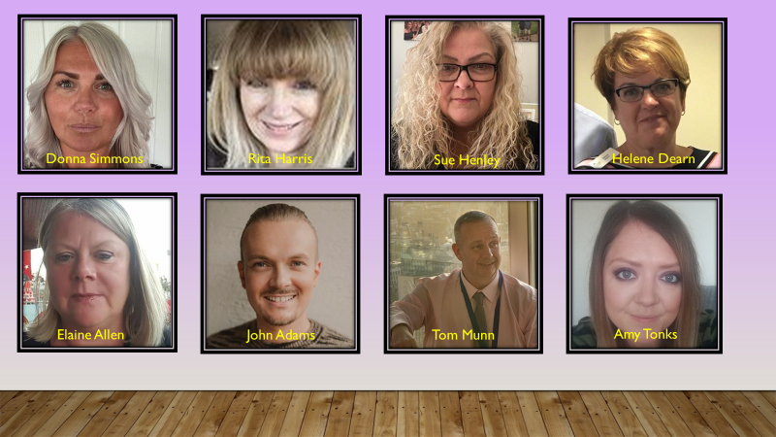
Figure 6 DWP Central MtW Team

