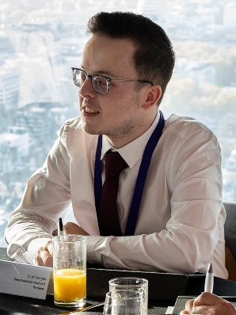
I would like to nominate Scott Keegan for the Rising Star Award.
I was first introduced to Scott when he was referred to the first ever virtual Movement to Work (MtW) placement within the Civil Service back in September 2020. Even then I knew he was an incredibly special person, and I could see so much untapped potential in him. It was during his placement; Scott spoke up and advised us how we could deliver virtually in a much more accessible manner. Scott has a unique understanding of accessibility as he is sight impaired and deals with this every day of his life - with the support of his guide dog and trusted companion Rae. Following this, Scott became such an influential part of the developing and testing of our new virtual programme and gave us so much insight into what, why and how to improve our delivery and resources. It is thanks to him that our Movement to Work placements are now the most accessible and inclusive than they've ever been.
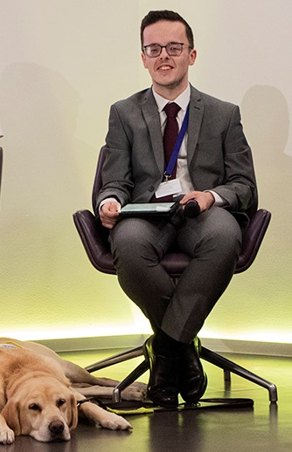
I often go to Scott for advice and insight, even now. He regularly helps me when I'm producing products for the DWP to use in MTW placements.
Since his placement, Scott has joined the DWP on an apprenticeship within Child Maintenance Group (CMG). He’s progressing well and is now supporting other young people that have joined DWP on a Kickstart placement. He has also taken a leading role in helping colleagues understand disabilities and has even delivered training in supporting sight impaired people in work.
Scott became one of the first MTW Youth Ambassadors for the DWP and the MTW Charity. He recently attended the 2021 Youth Summit in London, where he excelled as part of the youth panel and hosting a round table discussion. He continues to support the DWP central MTW team in promoting the programme within DWP and across government. His insight and passion to always help others, is something I am enormously proud of him for.
His work doesn’t stop there though. He is pro-active within his local community - always championing young, disadvantaged people. He is a member of the local youth parliament where he uses the space to highlight and champion diversity and inclusion for all. As part of his community work, he teaches dance to disadvantaged and disabled young people - giving them a space to feel safe and the ability to express themselves.
I would confidently say that Scott has personally inspired me. He has managed to influence how I think about accessibility and brought focus to the importance of this in all aspects of my work. He brings his own experiences of facing barriers with finding work and opportunities to the table and uses this to mentor his peers and upskill those who are in positions to offer support and hope to young people. Scott is an outstanding role model and MTW Ambassador and he deserves to win the Rising Star Award this year.

