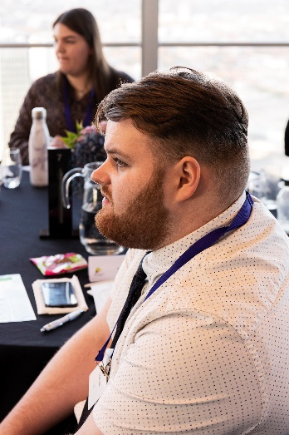
I would Like to nominate Gavin Phipps for the Breakthrough Star Award. Gavin is currently a MtW Movement to Work (MtW) Youth ambassador for both the Department for Work & Pensions (DWP) and the MtW charity. He does this amazing work around his full-time role as a Youth Work Coach in a Birmingham job centre.
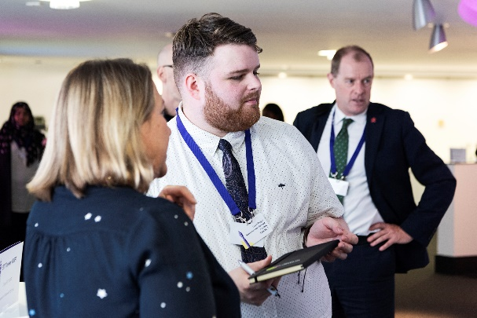
Nominating Gavin is a no brainer for me. He epitomises what this award is all about. During the pandemic, he faced some personal challenges. He was made redundant, experienced family bereavement, and went through a relationship breakup. This had a massive impact on his confidence and mental health. After some unsuccessful job applications and courses, Gavin admits he felt the wind had Been taken from beneath his wings, and that he would not be good enough for anything.
However, it was a MtW that changed his life. He participated in a programme within the DWP and during, felt seen, heard, and helped him for the first time. He built a fantastic relationship with his participant manager and found the confidence and resilience to try and apply for jobs again.
He soon joined the DWP on a full-time basis in a local job centre and has since been promoted – after showing great potential. I can see such drive and enthusiasm in everything he does - which is truly humbling. He is genuine, caring and has an empathic nature. He really listens to and understands people – which is a rare quality. I am proud to have him as one of our ambassadors and as a valued colleague. And cannot wait to see where his journey and career take him next.

