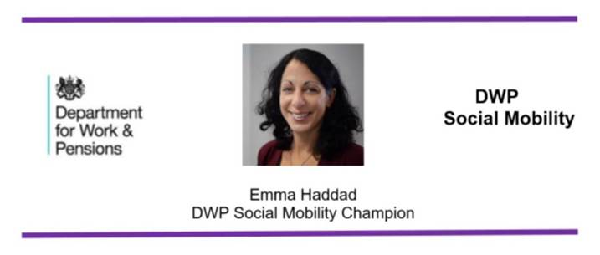
Dear Colleagues,
Last week over a thousand of you gave your time to support DWP’s Social Mobility Each One, Reach One mentoring event. I wanted to take a minute to echo the thoughts of the 2,000 colleagues who had a mentoring session, and personally say thank you.
By sharing your time and your experiences you have helped to break down barriers, build confidence and inspire so many people with their future career paths. I know this because the feedback we have received has been overwhelmingly positive with colleagues expressing just how grateful they were for your guidance, kindness and motivational feedback. You have made a real difference.
We have also heard from many of you about how much you enjoyed the experience and I know some of you have agreed to continue mentoring for a longer period. There have been many requests from both mentees and mentors for Each One, Reach One mentoring to be a regular initiative and so I am making this an annual Social Mobility event. In the meantime, if you would like to become a mentor on a more permanent basis then Mentor Match is a great place to start.
A very small number of mentees did not turn up to their allocated session as they felt overwhelmed and underprepared to speak to a senior leader, which proves we still have some work to do in continuing to break these down barriers and give confidence. For those who did take part, the experience was enriching and invaluable.
Some Headline figures
Over 47% (982) of mentees have provided feedback so far and they have told us:
- 66% had never had a mentor before
- 99% would look to have a mentor now
- 95% said Each One, Reach One had increased their confidence in approaching a mentor
- Over 88% scored 7 or more when asked how beneficial they had found their mentoring session.
I have included a few direct quotes from mentees below that I hope you will find as inspirational and uplifting as they did your sessions.
Many thanks once again for taking part and best wishes,

Emma

Emma Haddad
Director General Service Excellence and DWP Champion for Social Mobility

Feedback from mentees:

I thoroughly enjoyed having a chat with a Senior Leader. It always seems like an Us and Them and that they are out of reach. My mentor made me believe in myself and my vast amount of skills and that I can progress. I felt validated!!! He made me feel that I was not lesser than him, we are just at different stages in our career. That I should be more confident and aim high and be the bravest me.
My mentoring session was really inspirational. My mentor was terrific, I felt extremely at ease with her and gained valuable insight into how I can develop confidence and improve my skills in order to move forward. She has agreed to meet with me again which I am extremely grateful for as I know time will be limited it means a lot to know a senior manager would like to invest in me. Thanks for the amazing opportunity.
The session has taught me to believe in myself more. My mentor has given me the confidence and determination to succeed. Thank you so much again for this fantastic opportunity!
I just want to say 'Thank you' to my mentor for the most amazing conversation, guidance & encouragement.
Talking to my mentor was the highlight of my day!
My mentor was great and inspired me to do more promoting my strengths, but he also listened and heard my insecurities. He gave me hope!
Each one to reach one helped quash these insecurities and give me thoughts on how to push and motivate myself.
What a fantastic opportunity! My mentor really put me at ease and my confidence levels were really boosted by the end of the session. Thank you for giving up your time to speak with me, it was very much appreciated!
In these extraordinary circumstances, reaching out should be the primary focus for us all and you've just enabled that beautifully.
Senior civil servants often appear to be out of reach and unapproachable, but after my mentoring session I felt I could, 'Put a face to the name/title’.
I've always avoided this type of thing in the past, but have recently felt a little loss in confidence, so when it popped up I thought why not what can I lose! So glad I did, I had a fab session with such a positive 'real' down to earth mentor. I came off the session feeling uplifted, worthy and quite emotional (in a good way).
I cannot thank you enough for this opportunity. I have come away feeling valued and listened to and grateful that there are people in the department who enjoy giving up their time to support others.
The best 1/2 hour of my career so far!
I had a wonderful experience. It was so positive and upbeat as well as inspirational! I had an amazing mentor who didn't make me feel stupid for asking the questions I did or raising my concerns.
It was really encouraging to speak to a senior leader who was just so down to earth and human, who has no agenda other than to see someone grow and flourish. If/when I make it as a leader, I hope I'm half as wonderful my mentor.
Someone believes in me and now I can too!

If you have difficulties reading this bulletin because you find the text size too small, try holding the Ctrl key and using the scroll wheel of your mouse to scale the text up and down.

