Better Late than Never – (Nikita’s Blog)

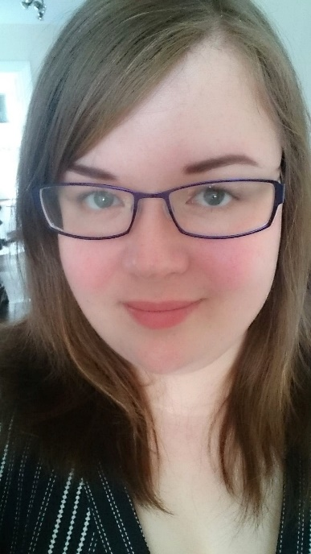

My name is Nikita and I want to talk to you about social mobility. I was recently appointed as a DWP Social Mobility Network Ambassador and will be representing the North East, Yorkshire & The Humber regions.
Social mobility is something that I feel really passionately about because I know from a personal level how important it was for me to break free from my barriers and achieve my potential. If you have ever felt like the odds were set against you, maybe this will resonate with you.
I live in Ashington, Northumberland but I was born and grew up in Birmingham. My family lived on a very working-class council estate. The irony being that hardly anyone on my estate worked.
My parents were an on-and-off-again couple; my mum had an on-and-off-again job as a bar maid, and my dad - as far as I can remember - never worked.
Funny side story, when I was in year three or four and we were talking about parents’ jobs, I proudly announced to my class “my dad is a dosser” having heard it but not knowing the meaning. Apparently, everyone else did. (Cue flashbacks of class laughter)
My parents had 6 children together, but I have 9 brothers and sisters in total. In case you’re wondering, for Christmas my dad would unscrew the kitchen door, lay it over our coffee table and put a sheet over it so that it would be big enough for us all to squeeze on… Albeit a bit lumpy and unsteady – “Elbows off the table!” was less about manners and more about keeping the food on the table.
I went to a primary school where uniform was optional, but if you wore it you got to sit on benches for assembly. I sat on the floor until year 6. We didn’t have the money for extra-curricular activities, driving lessons or anything like that to help get us off to a good start. I was a gifted child though and achieved well in school, but despite this I still fell into the statistic and grew up to be an adult on benefits.
By the time I was a teenager, my parents drug dependency had escalated and I got into a bit of trouble because I was angry with my parents and the social services that kept failing me.
Throughout my adulthood I struggled with various barriers, and it wasn’t until I was given an opportunity, at 27 years old, that I was able to change my mind set to overcome them, flourish and become the person that I am today.
It still surprises me today; in the things that I do and the emails that I write… My inner critic thinks “I can’t believe how professional I’m pretending to be” ...I’d get into it, but that’s probably a whole other blog in the making. #impostorsyndrome But I digress.
It’s been two and a half years since I started working as a Civil Servant. I’ve worked with some inspiring people and I’ve made some good progress. I’m really pleased to share that I have made it to the next grade now (EO; start date pending) But that’s only the start - I have something to prove to my 20-something past self who stopped believing in herself and never would have thought that this would be possible, and for my younger and more naïve past self who dreamed of achieving the world.
If you would like to read more about my story and where I started, I wrote another blog last year for National Inclusion Week called Movement to Work and Me.

Our aim
The aim of the DWP Social Mobility Network is to advance and champion Social Mobility throughout the department, supporting in the delivery of our Social Mobility Action Plan to create a more diverse and inclusive workforce.

We want to improve our socio-economic diversity by increasing opportunities which are accessible, fair and representative to everyone. We believe this is key to our vision for a brilliant civil service because creating a diverse workforce opens the gates to a wider stream of talent.
You can read Emma Haddad's statement and more about what we are doing on the Social Mobility intranet pages.

What do we mean by social mobility?
Social mobility is the movement of individuals up or down the ladder of social classes.
It is the idea that where you start in life, should not determine where you end up and that everyone should be able to advance as far as their hard work and talent will take them.
It is the link between a person’s occupation and income versus their parents’: where there is a strong link, it shows there is a lower level of social mobility. Research found that people from “better off” backgrounds were almost 80% more likely to be in a professional career than their working-class peers.
You can read more about the disparities between different social classes and the challenge we face in The State of the Nation report. (link is external)

How can I help to take this forward?
All successful projects start with data gathering and analysis. For us to gauge how far we need to go to reach our target, first we need to measure the current representation of different social classes across the Civil Service.
To do this, SOP has been utilised to help gather the information. Under “My Personal Information” there are some optional questions which I would encourage everyone to complete.
To find these on SOP, go to My Personal Information > My Further Information > My Diversity Information and complete the section for socio-economic background.
The questions ask about your qualifications, your parents’ professions and your eligibility for free school meals as a child, as these are all measures and indicators.
I understand that these questions have been met with apprehensiveness and scepticism by some because the reasons for them were unclear, so I hope that I have clarified this but I am open to conversation if anyone would like to learn more.
Alternatively, you will find a wealth of information about the state of the nation and social mobility indicators linked above.
Another way that you can support the movement is by joining the conversation in The DWP Social Mobility Network
and being an advocate. If you have a social mobility story, we’d love to hear it! Or if you have any ideas, please share them with us. Positive change starts with all of us. Together we can turn the tide on social divide.

