Case Study: National Careers Week (March 2021)
For many schools, planning of National Careers Week this year was not possible due to capacity being stretched and pressures of supporting students to return face to face. Schools also described a huge need for employer engagement and careers support that many had lost out on due to the pandemic as well as also being reluctant as to how this type of week would look in practice. WORKS met with the school leads to review priorities of their students and where gaps in engagement and learning was currently as well as suggesting some employer engagement to explore university, apprenticeships, signposting to careers support and employer engagement. Based on these discussions and aligning to the Gatsby Framework, WORKS collaborated with employers to design a jam-packed week to support both mainstream and SEND schools to build momentum for a virtual careers week.
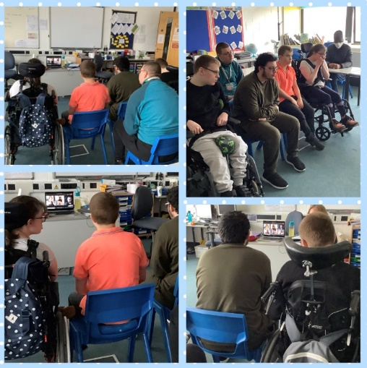
In partnership with WORKS delivery partner, Sixteen, 26 live sessions were delivered across the week equating to over 540 experiences of work to students in Bristol.
On Monday, sessions from Avon Wildlife Trust and ENGIE gave students an insight into the types of careers available within gardening and construction respectively. These were interactive and practical workshops delivered across years groups.
Tuesday saw the National Careers Service advise students on how to decide what to do when they leave school and the differences between university and apprenticeships and where to go to source further information across their next steps.
Throughout the week students also had the opportunity to attend ‘reverse interviewing’ sessions where students were invited to ask questions to employers including A Cappella Coffee, Avon and Somerset Constabulary and Woofers Dog Groomers. There were also live myth busting sessions with law firm Burges Salmon challenging some of the misconceptions about who can enter law and lawyers sharing their untraditional career journeys and routes into the profession.

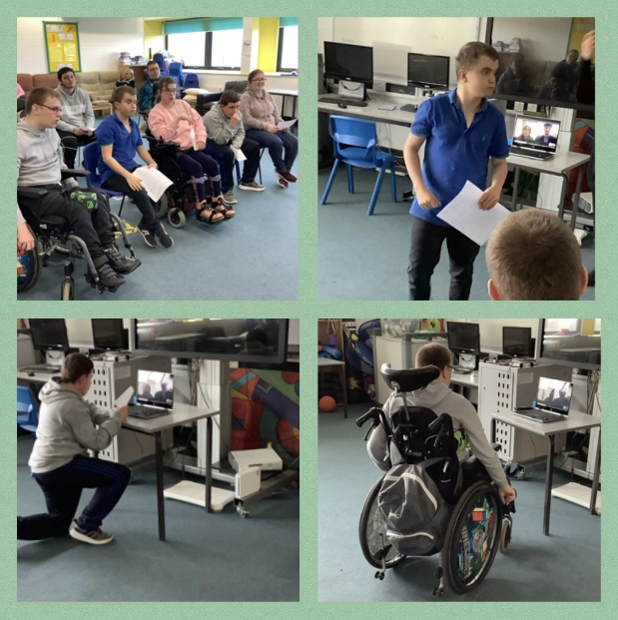
On Wednesday, Bell Group shared their career and apprenticeship opportunities available within their organisation and the inspiring stories of current employees who worked their way up from apprentice to director including opportunity to see pictures and projects of current apprentices. Students also had the chance to watch a behind the scenes tour of Bristol Old Vic theatre and Waitrose and then attend a live session asking questions relating to this including how their roles have adapted during the pandemic and exploring what future career options may look like in these fields.
As part of this day, an event was being delivered for mainstream students on a virtual platform which many students with additional needs were having difficulty accessing and navigating. To ensure students did not miss out on this and could access this meaningfully at home or at school, WORKS designed a private page and resource of activities to work through with teachers or parents capturing the event more inclusively and pitched to the level and needs of the group. WORKS curated live sessions and activities for over 300 students with additional needs to engage with.
TV Professionals from True to Nature told students about their career journeys and gave advice to anyone looking to work in the TV industry on Thursday afternoon and shared information about how to apply for future work experience and apprenticeship opportunities here.
Finally, Friday saw a session from University of Bristol Life Science Department, all about the benefits of a career in STEM (Science, Technology, Engineering and Maths) and the opportunities at the university. Sixteen were also busy on Friday, delivering four separate ‘When I Grow Up’ sessions to students with additional needs giving lots of practical advice on entering the world of work and exploring what appropriate behaviour in the workplace looks like.
97% of young people reported that the session was useful or very useful in thinking about their future, with 96% also reporting that they would use information from this session to help make decisions for their future. Over two-thirds of students indicated that the sessions made them feel differently about their future in a positive way. A Year 11 Student at Kingsweston School who attended several sessions this week said “This year’s National Careers Week has been really useful because it has shown me different things that I can realistically do and it has given me confidence that I can get a job in the future and how to get there”.
The majority of feedback provided by school staff regarding the National Careers Week sessions was qualitative and related to specific events as set out in the sections above including:
“Working with Bristol Works has allowed for a number of virtual opportunities for our young people to access and explore the World of Work. Having worked previously with Bristol Works they have a real understanding of our young people's needs and were able to support putting in place employer encounters during National Careers Week that were meaningful, accessible and inspirational. Our young people were able to successfully prepare for the live sessions, having had time to prepare questions and explore the companies further with the use of pre recorded content. It was great to see our learners engage so well and confidently as well as continue their discussions even after the sessions had finished! They are already looking forward to and asking what else is lined up – we could not have done this without them”.
“I just want to say a big thank you to all the work you have done this week in preparing and delivering the sessions to our pupils, as well as replying to each of them and giving them encouragement to join. I have been really pleased to see our students attend these sessions and I believe it's really helped them to see what's available and has injected some real positivity into their lives during a really tough year… a great effort was given to informing students of a range of careers and real encouragement from young and experienced employees from a wide range of sectors. It's definitely ticked the ‘raising aspirations’ box”.
“Just wanted to say a huge thank you to you all for pulling all the sessions together at Knowle DGE this week. We had some really positive experiences for the students, and it was our biggest careers week yet. There was an amazing variety of options which gave our students some good insights into the world of work and this was very much needed after the last year”.

