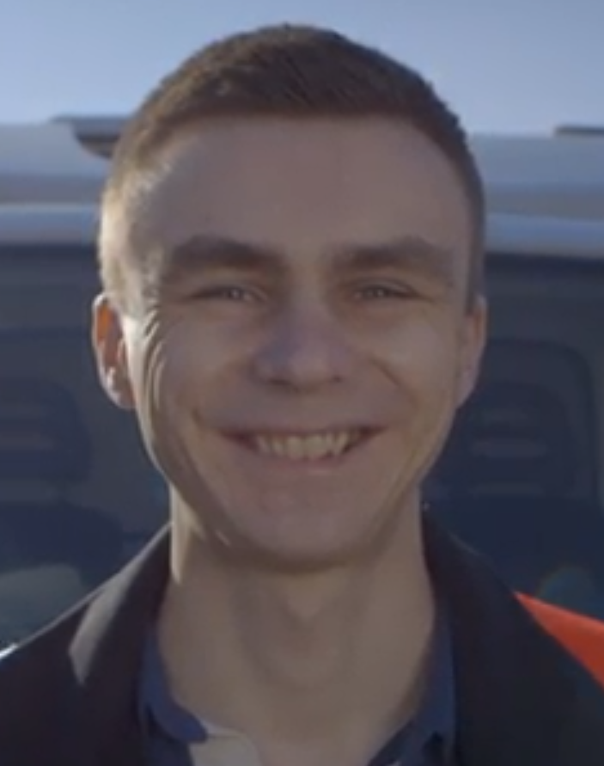

Please see video link:
https://www.linkedin.com/feed/update/urn:li:activity:6509392151967866880/

