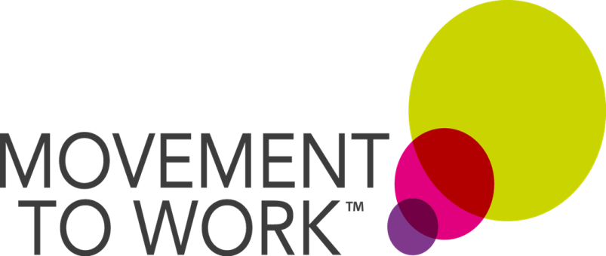

Case Study Template

Please take some time to fill out this template and then send it back to the Movement to Work team so that we can spread the word about Movement to Work and the good things we’re doing.
Please print and fill out the DWP Consent form at the end of this document for both yourself and the Participant, and include a photo of yourself and the participant (together or separately is fine).
Please return to: MOVEMENTTO.WORKSCHEMEADMIN1@DWP.GSI.GOV.UK

Name of Participant Manager:………………………………………………………..
Name of Participant:……………………………………………………………………
Location of Work Experience Opportunity:………………………………………..

Tell us about the Work Experience Opportunity: e.g. Laura took part in a Work Experience Opportunity as part of an admin team in HR Strategy. During this time, she delivered a project on wellbeing at work, where she did X, Y and Z.

Where have you seen the most development in your Participant? E.g. I’ve seen a big change in Laura’s confidence during the opportunity. On day one, she barely spoke to anyone, but during the last week she led an engagement campaign with bags of confidence

Where have you seen the most development in your own skills? E.g. I have really seen an improvement in my communication skills over the last three weeks, because….

What next? E.g. Laura has secured a job at X or will apply what she’s learnt to her future job applications. I’ve loved the experience and will host another MtW participant in the future!

Additional Comments:

Participant Testimonial: Please get the participant to write a short piece about their Work Experience Opportunity, what they enjoyed, what they learnt, their hopes for the future etc.

Promoting Department for Work and Pensions (DWP) and Jobcentre Plus services
We would like to use your recent experience as an example to tell others in similar circumstances how DWP and Jobcentre Plus can help them. We call this a case study or good news story and it is used to show how our services relate to people in a realistic and practical way.
Your story could be used in a number of different ways and we need your consent before we can use it.
How will my story be used?
- We may use your case study in local, regional, and sometimes national, newspapers (also known as the press). We would like to use your photograph to accompany your case study wherever possible. Occasionally, we might want to interview you to gather more information.
- We may also use your case study in various magazines, leaflets, newsletters or on websites.
- We may refer to your case study on a radio station.
- DWP Ministers sometimes use case studies when speaking in Parliament or making speeches.
In some cases, we can use your case study without using your real name if you wish to remain anonymous.
Please tick () the boxes below where you agree to give your consent:
I give my consent for the DWP to use my case study in the following ways: | To use my name | To use  my photo  (if required) |  | To use my story but not my name
In newspaper articles |  |  |  | Not applicable as newspapers must always use real names.
In leaflets, feature articles (magazines) or digital media (websites), radio, local newsletters etc

In DWP Minister’s speeches or written reports

I would like to see any article that features my case study before it is released – please tick () whichever applies |  |  | YES |  | NO
I agree and understand:
- My case study may be used for up to 12 months. After this, it will no longer be used.
- This form will be kept for 24 months. After this, it will be destroyed
- I can withdraw my consent to the DWP using my case study at any time

Signed: Date:

