Journey of discovery – IBM Ignite Trainee to IX Apprentice
Alexander Best

My journey began in January 2017 when I started on the City Gateway traineeship and successfully gained a 5-week work placement on on IBM’s ‘Ignite’ program. I was placed within IBM’s Brand and Communications team in the Marketing Department where the team focus on raising the profile of IBM in the UK & Ireland. My role was challenging and extremely varied and included a range of activities; supporting the Brand Systems, Internal Communications & External Relations teams. My day to day activities included the management of their social media channels, communication platforms, creation of social copy, newsletters and the filming & editing of presentation material.

My role and the support of my IBM team and mentors allowed me to gain experience working in a corporate environment, developing my skills, employability, building relationships and an extensive network of IBMers.

I received excellent feedback from both my team and the Ignite leadership over the course of my placement and my team were keen to find a opportunity to bring me on board on a paid placement.

Following the success of my placement and the professionalism and dedication that I demonstrated on my placement, in May 2017 I was offered the chance to return to IBM for a year as part of Futures programme. I returned to the Brand & Communications team replacing their current intern, which was a first for the Ignite program. During my Futures year my role evolved and expanded as I demonstrated my skills and further gained the trust and respect of my team. This led to deeper and more challenging roles increasing the level of my responsibility in the team. I successfully delivered the publishing & distribution of IBM UK’s internal newsletters, created infographics and images for communication platforms and collaborated with external agencies to release brand advertisments for different levels. My experience was life changing. I knew that IBM was where I wanted to be and I was keen to take on my next challenge.

After investigating the opportunities available internally and support from the Ignite management team, I applied for an IBM apprenticeship in Digital Services (known as IX). I was offered an opportunity to fast track onto their programme due to the success of my Ignite and Futures placements. I am currently on the Junior Management Consultant pathway working as a Project Management Office for a large financial services client. The Ignite experience was a crucial step in achieving my apprenticeship and enabled me to lay a foundation which just over a year later is demonstrated in business results, skills, networking and career progression.

Through my role in the business as a managing consultant I’ve had the opportunity to work with many of our clients and business partners. These include key clients in financial services, media & communication, and public utilities.

Since my graduation from the Ignite program I have made it a priority to maintain an active involvement in the ‘Ignite’ program to share my experience and support the trainees in a variety of ways and with the wider MtW community

- delivered and facilitated communication skills sessions;
- delivered presentation skills sessions
- acted as a mentor, providing guidance and working with the trainees to build and define their goals and milestones.
- Led education to deliver Acclaim Open Badges as part of the program on Cyber Security. This involved guiding the trainees through an online interactive badge, facilitating discussion and supported by a presentation deck that I designed to supplement the badge.
- Represented Ignite both internally and externally, including presenting at Movement to Work quarterly meetings
- TV appearance on the WOW show.

I feel a sense of pride that my dedication to helping the trainees get the most out of their time in IBM has shown results and has been influential in two more trainees being given full-time roles in IBM.

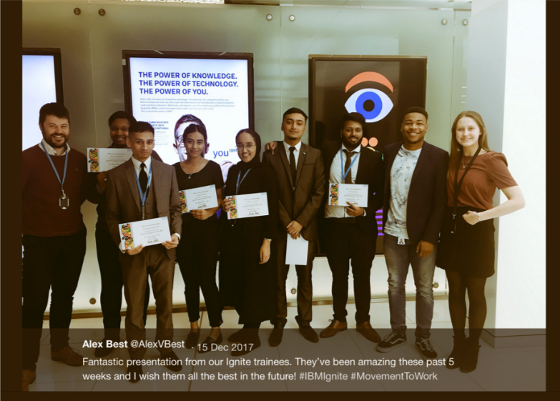

To raise further visibility of the Ignite program, every year an internal Ignite launch event is hosted in South Bank by the Ignite team. Prominent members of the scheme are invited to explain the Ignite program, what it is, and how we are supporting the program to tackle the problem of youth unemployment numbers. I’ve been privileged to be invited to share my story and showcase the impact Ignite is having and gain wider support for the program. I’ve received amazing feedback from managers and attendees who have mentioned that my presentation had a big impact on their decision to get involved in the scheme and help make a difference.

As an ambassador for IBM and the Ignite program I have been nominated to attend and represent IBM at external events, the most prominent being my TV appearance on the WOW show. The show is an online platform designed to bridge the gap between industry experts and students looking for guidance on educational and career decisions. I was asked to attend as a Technology expert and during the live shooting of the show, shared my experience and answered questions raised by students regarding careers in IT & technology.

- I have also represented the programme and the Movement to Work Quarterly Employers’ Event earlier this year, giving a presentation showing the progress and improvement trainees can make once they go through the programme.
- In February 2019, I attended the Movement to Work CEO Summit and Social Mobility Awards. Click here to see a highlight video of the event. I have a featured role in the video which clearly explains my motivation for attending the Movement to Work event.

- In September 2019 attended the 5% Club event, an employer forum focused on developing skills and apprenticeships in the early professionals’ workforce. The event was themed around Apprenticeships and Career starters. I was invited to join a Q&A panel discussion with other young professionals who have come through a Movement to Work programme and gone on to complete an apprenticeship.
The IBM Ignite programme is a fantastic initiative that over 250 trainees have now taken part in. I am proud to have been one of them and provide ongoing support for the programme and I am excited to see the programme grow and develop this year.

