IBM UK – Ignite Work Experience Programme
‘A program with a difference’
As a member of the IBM Ignite team since inception and current program leader, I can only describe my involvement in the program and the MtW initiative as passionate, personal and heartfelt. Let me take you on a journey of how myself, my colleagues, the trainees and an extensive team of IBM volunteers are stepping up to make a difference.
Our IBM ‘Ignite’ program provides a mix of quality work experience and training for young people. As an employer we take on over 300 Early Professionals each year into our Apprentice and placement programs and as a company have the skills and knowledge to step up and help young people who are looking for work. For IBM the program isn’t about recruitment it’s about giving everyone the skills and confidence they need to take the next step, regardless of what that step may be.
We want to help break the cycle of ‘no work experience so can’t get a job’ and offer skills and employability training alongside practical work experience.
We have focused our programs on areas with the highest levels of childhood deprivation in the UK, so we partnered with an amazing East London charity City Gateway, supporting their work readiness programme, adding real work experience, for young people aged 16-24 from disadvantaged backgrounds. Seeing first-hand the impact the programme has made inspired us expand the programme and we now run a second program from our Hursley office in Hampshire in partnership with Hampshire County Council.
Over the course of the year we have supported trainees with a variety of challenges, barriers to employment and personal support needs, including gang related incidents, family issues, young carers, Asperger’s, Autism and mental health issues covering anything from anxiety and depression through to multiple personality disorder and schizophrenia.
We run 4-8 cohorts over the course of the year with roughly 8-14 trainees per cohort. We focus on small groups of trainees providing an individual and tailored experience for each trainee. The numbers are not the focus of our program but the outcomes and impact to the individual really are and we pride ourselves on the time and experience we can share with each of our trainees.
The application process
During the programme trainees ‘apply’ for work experience via an application form and are invited to an IBM assessment centre to be assessed through individual presentations, group exercises and interviews.
Just stepping through the doors at IBM can be overwhelming, so the assessment is gentle and takes into consideration the circumstances of the individual candidates. A passion for grabbing opportunities and the courage to step out of their comfort zones is what we’re really looking for at this stage.
Each candidate is carefully matched to a real role with a dedicated task manager and mentor to best meet their needs and career aspirations. They then join IBM the following week to start their four-week placement.
What the program looks like
The Ignite programme is sponsored by the UK CEO and managed by a full-time programme manager and a whole army of IBM volunteers. Engagement is on-going throughout the year with our mentors, task managers and partners and the program is constantly evolving based on feedback from both the trainees and volunteers.
The entire programme is designed to provide the trainees with self-confidence, employability skills and work experience so they can create a fantastic CV and have the confidence to go out there and get that job. Each week provides a mix of work experience and ‘back to base’ days where we focus on areas such as communication, presentation and employability skills which then evolves into putting those skills into action in different situations.
We have designed an in-house program delivered over 4 weeks incorporating 13 days of work experience and 7 days of training. The programme hosts small cohorts of 8-14 trainees to ensure a high level of individual support and a tailored experience.
During ‘back to base’ days, we use a range of engaging and fun activities to build their confidence week on week challenging them in new ways and pushing them outside of their comfort zones, until finally we challenge them both internally and through external organisations to put their new knowledge and skills into action. Internally we engage them in Hackathons, Design thinking workshops and Careers events and externally through, Avon Tyrell outdoor activity centre in Hampshire providing volunteering and team building activities. External escape rooms challenge such as ‘Clue Quest’ showcase their strengthened competencies in a fun environment like that of a corporate assessment centre.

The program includes
- 2-day Induction
  - getting to know the IBM Ignite team
  - getting comfortable in the corporate environment
  - IBM overview
  - Icebreakers and team building activities
  - Communication Skills
  - Professionalism
  - Laptop set-up and tools
  - Meeting task managers and mentors
  - Health & safety
  - Presentations and games, including activities such as origami, hula hoops, IBM hangman, quizzes and videos.
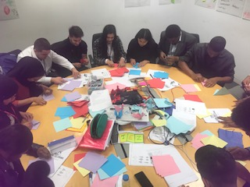
- Technical base days
  - Design Thinking Workshop – designed and delivered by one of our IBM IX Apprentices, brings creativity and presentation skills into practice.
  - Tech Day – hosted in our Hursley office, the trainees have an early start and catch the train down to Winchester to spend the day in our Technical base. They can explore the IBM museum taking them on a journey from cash points and storage through to first laptops and tablets and everything in between. We then move through the day with a technical focus on how they engage with technology and close the day with a tour and activities in our Emerging Technologies Lab, showcasing technical thinking around facial recognition, IBM Watson, Augmented reality, providing a snapshot of technology really can do!
- Volunteering day – Avon Tyrell in the New Forest, assisting in maintenance of the site, activities have included clearing bushes, cleaning, painting and provide another external opportunity not only to build their CV’s but to put the key competencies into play externally.
- Employability skills
  - Focus area from application stage through to Final presentations
  - Guest speakers including Early Professionals and IBMer sharing their ‘non-standard’ routes into IBM, from Footballers to fork lift truck drivers.
  - External Escape room – we take every Ignite cohort to Clue Cappers a London based escape room to put their competency skills into proactive in another new and challenging environment.
- Final Presentations
  - Individual presentations – covering background, Ignite journey, role, base days and challenges.
  - Group presentations – these presentations have seen the cohorts turn the tables on the trainers and engage is a range of activities in a formal presentation including, snakes and ladders, raps, pictures, quizzes, Cahoot games and even music chairs!
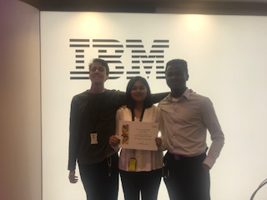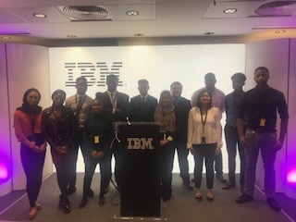
The quality of the work and opportunities
Each trainee has a Task Manager who they work with day to day and a personal mentor to support them and enable them to make the most of their time at IBM. Day to day and pastoral support is provided by a specialised Ignite programme team and safeguarding support from City Gateway.
We provide challenging roles across our business areas and focus on matching the trainee’s previous skills and experiences with the roles available along with tailoring placements to their future aspirations and career goals. Trainees have worked in the CEO’s communication team, Wimbledon Brand and Communications team, Client Centre management, recruitment, operations, acquisitions and in our IX design team.
We ensure that we provide suitably challenging and relevant work experience that will stretch the trainee whilst allowing them to develop transferable soft and relevant “harder” skills which they will use in most future jobs.
Additionally, trainees must complete a placement journal to documents their goals and achievements and are challenged to complete 15 work-based CV building activities during their time with IBM. Challenges include running a conference call, completing a Tech Partnership ‘badge’, demonstrating digital skills, connections on LinkedIn, get a work reference, presentations and networking.
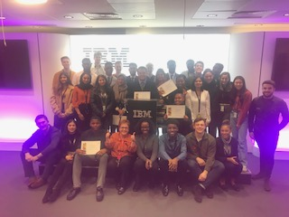

The programme and beyond
In addition to a task manager, who is responsible for their day to day activities trainees are also carefully matched to a mentor. The mentors encourage the trainees to make the most of the opportunity, supporting their 15 challenges, finding shadowing, offering careers advice, CV skills and preparing them for final presentations.
We don’t forget about the trainees once they’ve left IBM. Our charity partners work with the trainees to find suitable roles or training.
The aim of IBMs Ignite programme is for at least 50% of trainees to find work or return to education within 6 months of completing the programme. The entire programme is designed around this and we are proud to say that IBM’s results continually exceed this, reaching up to 56% overall and up to 70% for our London based program.
During 2018/19 we have been able to fund Short term Placements for three Ignite trainees from CSR, two of the three placements have led to longer term employment with IBM. One as a full time IBM in security and the second with a 6-month secondment to our GTS business in the communications team. The placement has been such a success that we have agreement to provide the same again in 2019/2020 and we already have two candidates that we are looking to make offers of Short-term roles, with the hop that they will lead to longer term opportunities in the business.
The trainees are supported by the IBM Apprenticeship and Futures programme leaders and we have successfully hired nine Ignite trainees onto our Futures placement program and three have progressed onto our award-winning Apprenticeship scheme. We have created a fast track process for both programs and are providing new level 3 apprenticeships to better meet the needs of the trainees. Outside of IBM, many trainees have found quality apprenticeships including the London Stock Exchange, Accenture, Man Group, Ofcom and Clifford Chance.

