“Each One Reach One”

An Opportunity to Engage
Dear Colleague
Following National Inclusion Week your Senior Leadership Team members want to reach out and offer you the opportunity for a 1-2-1 conversation with the us during November and December.
Who can I talk to?
It could be with anyone in the senior leadership team that you would like to engage with.
What can I talk about?
You can talk about anything you like. It could be about inclusion; it could be about your career or maybe advice about your own development.
It could be a mentoring conversation or just a getting to know you conversation.
How do I get involved?
1. Have a look at the list of SLT members below and the slots on offer
2. Email [redacted] by 27 October putting Each One Reach One in the subject line and with your preference
3. Your SLT colleague will then send you an outlook calendar invite back to confirm your time with them and the Skype Link/ Phone number that you will need to use.
What if all the slots go?
If we get lots of take up the SLT member that you want to engage with will offer you an alternative slot.
If this does happen, please be patient and be aware that we may have to arrange your session in the new year.
We look forward to speaking to you soon.
Have you been thinking about having a mentor but want to test it out first?

Then book 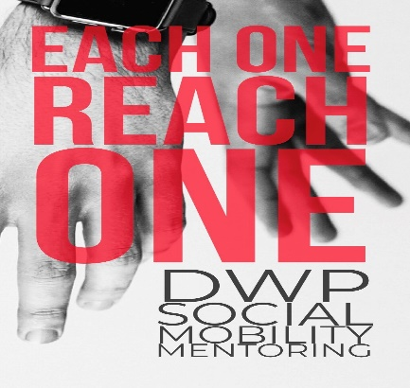a one-off mentoring session with a senior leader

through our DWP Each One Reach One mentoring scheme. Throughout National Inclusion Week, over 1000 senior leaders will be hosting 25 minute mentoring sessions, meaning we have over 2000 slots available for you to choose from.
You can view the times available and book a session on Eventbrite.
Having someone outside your line management chain that you can talk to about work, life, ask questions and gets view from, can be invaluable. However, knowing how to find a mentor or even whether you want one can be a daunting prospect. We are keen to encourage all colleagues, especially our AA, AO and EO colleagues to find a mentor and this offer may help you decide if mentoring is for you.
You may be surprised to learn that many famous people have been mentored too from many walks of life including Christian Dior mentoring Yves Saint-Laurent where Saint-Laurent learned the secrets of the haute couture and how to run a company.
Even President's have benefited from mentors when Michelle Robinson (now better known as Michelle Obama), was designated as Barack's mentor at the law firm where they both worked while he was a summer associate. Barack often credits Michelle today as being the support and success behind his great achievements.

