Bell Group UK – Kim Lawrence, Social Value Programmes Development Manager

As a business it can be a challenge to access schools. The construction industry has a massive skills shortage and a lack of diversity at all staff levels so being able to connect with young people, teachers and parents is key to us developing and maintaining our skills pipeline and diversifying and inspiring the workforce of the future. As a large contractor we also have a duty under the Social Value Act to work with young people in schools.

Hayley and her team at Bristol Works have provided an invaluable service in brokering that access for us, helping and supporting us deliver a range of innovative and relevant content to young people and providing expert advice and guidance on best practice. As a result they have enabled us to work with a wide range of young people based in mainstream, alternate provision and SEND schools across Bristol. In addition, they consistently come up with interesting ways to connect with students and we have always jumped at pretty much every single opportunity to work with them! This has been particularly pertinent during lockdown as schools closed their physical doors. Within a few weeks of the announcement in March last year Hayley was in touch, asking us to participate in a project to create a series of career films and online Q&A sessions for young people. We gladly took part, and with their guidance and support created four career insights films which were accessed by over 200 young people.

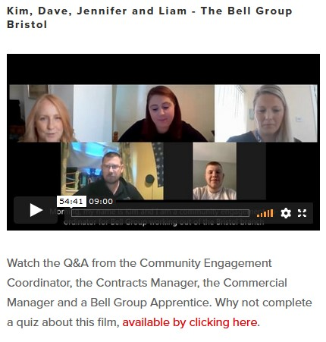

Here are some other examples of how our partnership with WORKS has helped us to connect with young people in schools:

1. A young student was directly recruited to our apprenticeship programme as a result of a WORKS workshop we did in an Alternate Provision school in 2020. That 17 year old young man is now a first year apprentice with us working towards his level 2 in painting and decorating and is one of our most promising apprentices.

2. WORKS partnered with us to co-create our international virtual work experience week called Global Youth Construct. Hayley provided support and expert advice, helping us programme and schedule the week’s timetable, recruit young people and ensure content was relevant to the students. During the week her and her team ran and participated in a number of virtual workshops, demonstrating the wealth of skills and experience they have in engaging and motivating young people. We would not have attempted this highly ambitious project without Works as a partner. The week was hugely successful, engaging young people from across the UK and Ghana in 39 workshop sessions including a headline challenge task, Skills Audits, Speed Interviews, Industry Insight sessions, Q&A sessions, industry and leadership insight films and Careers Insight workshops. By the end of the week the students:

- Understood many of the different elements of a construction project and how they fit together.
- Worked with and learnt from other young people from across the UK and abroad.
- Gained an insight into the huge range of careers on offer.
- Understood the wide range of skills required in the industry and learned and practised those skills including: Listening, Speaking, Problem Solving, Creative thinking, Team Working, Leadership, Decision making, Asking questions, Developing a positive attitude, Willingness to learn, Time management and researching.

It should also be noted that one of the Bristol students commented - “I would just like to thank you for this amazing opportunity you have given me but also the insight on how much there is to learn about this world. I have grown in confidence and passion and self-belief more than I could’ve ever imagined and I just want to thank you for everything you have done for me. It’s been a pleasure working with you and the team you brought and I am humbled to have been a part of this”.

3. We are delivering with WORKS a number of Virtual Careers Insight sessions with a number of schools including SEND. These sessions have allowed us to share with young people our passion for our industry and the wealth of careers and apprenticeships on offer to them. The opportunity has also helped us to develop the confidence of our young apprentices who also participate, discussing their school and careers journey with the students and sharing their portfolios of work. These have proved to be highly successful. In addition, these online sessions have encouraged us to bring in staff members from many different departments of our business to engage with young people in ways we wouldn’t have been able to do pre-Covid.

4. We are currently working with WORKS on their Discovery Box series, an innovative project to enable sensory impaired students to discover different jobs and careers through sensory experiences. This is a fantastic idea, enabling us to reach young people who we would normally find difficult to engage and we look forward to filming our section in a couple of weeks.

To summarise, WORKS are our ‘go to organisation’ when it comes to expert advice, ideas and support on how we can best connect with teachers, students and parents. They are key to us reaching young people from a range of backgrounds from across Bristol as we grow our Schools Online programme in partnership with them.

