**Yaamin Nanlawala**

These examples demonstrate Yaamin’s attitude of hard work, determination and sense of community spirit to help others is a powerful combination and make him a Rising Star.

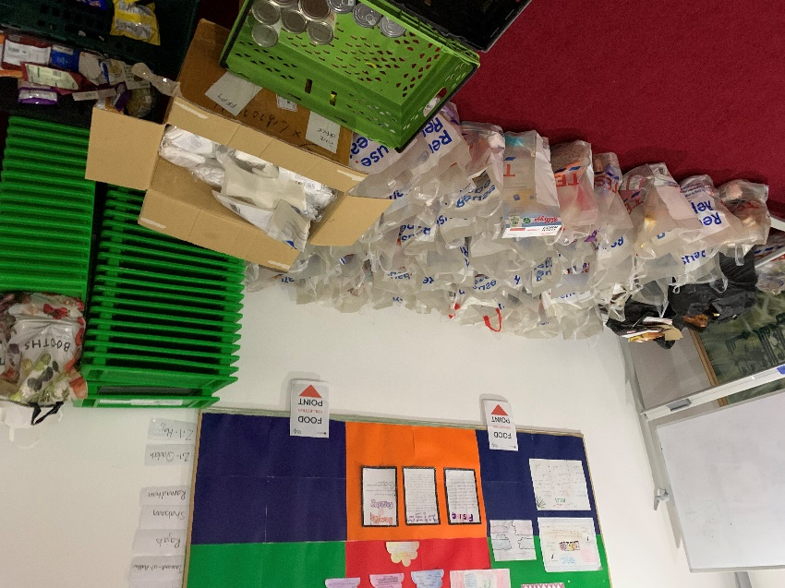

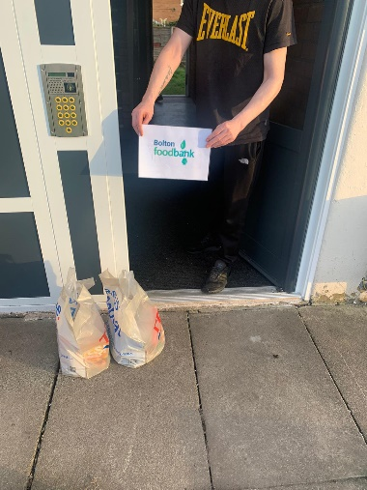

Above right: Contactless delivery being made in the local area.

Above Left: Food Packages being prepared for delivery at the collection point.

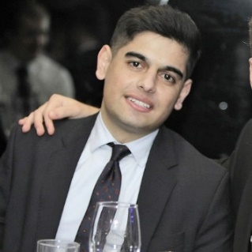 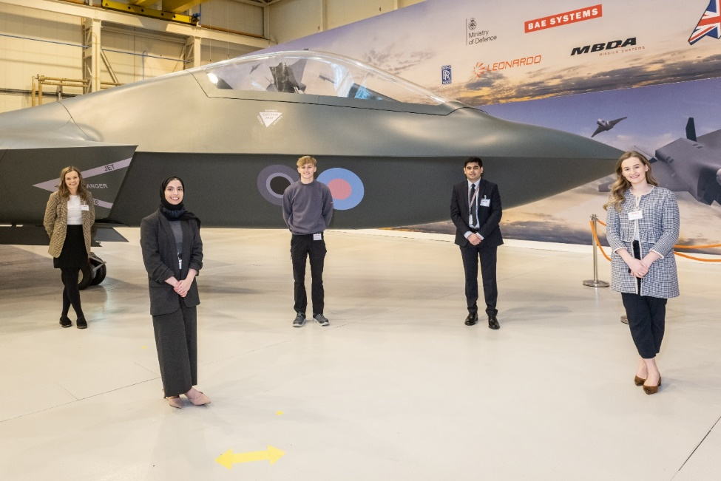

Above left: Yaamin

Above right: Yaamin stood by Tempest concept model and with other apprentices and graduates from BAE Systems

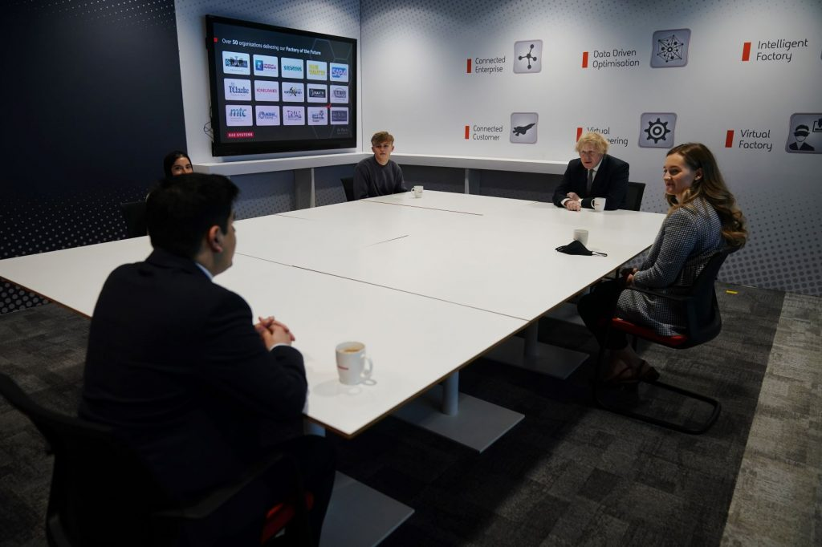

Above: Yaamin in conversation with Prime Minister Rt Hon Boris Johnson.

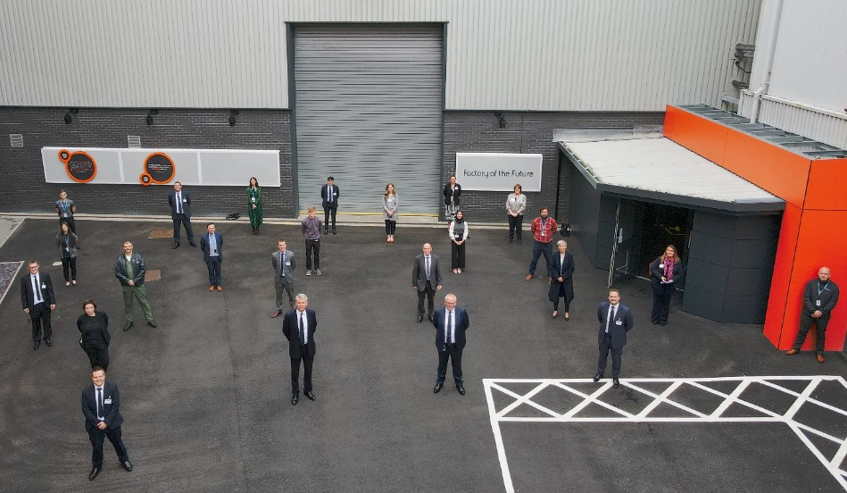

Above: Yaamin with Dr Charles Woodburn, CEO and the BAE Systems Senior Management Team awaiting the arrival of Prime Minister Rt Hon Boris Johnson



[twitter.com](https://twitter.com/BorisJohnson/status/1374078731279593472?s=08) twitter.com/BorisJohnson/status/1374078731279593472?s=08